Wednesday, 18 May 2022

Dear parent/carer,

**Re: Information on Student Finance and Budgeting (updated 18 May – original letter sent 10 March)**

As you may know, applications for student finance, for all students commencing university study in 2022, are now open and students have until 20 May to make their applications.

To support students through this process, the University of Huddersfield delivered an extensive information session to students during Tutorial last week. They have kindly agreed to record a similar talk for parents and carers, which may be accessed via [this link](https://heckgrammarcouk-my.sharepoint.com/:p:/g/personal/roxby_heckgrammar_co_uk/ESa8iFcyfwpNqeVQ6muuRAABFgV8UeFluH7O59EHHinAcQ?e=CckhWv).

I hope you find this information useful and informative.

Yours faithfully,

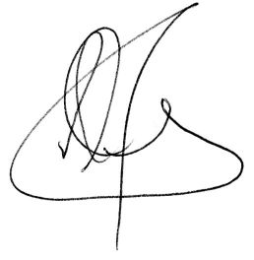

Mr R N Oxby

**Deputy Director of Sixth Form (Progression)**